
Year 10
Pathway 2

Test 1
Total Marks: 26 marks
Name: ____________________________ Total Time: 30 minutes

Show working and answers on this sheet. Show working in sufficient detail to support your answers. Incorrect answers without supporting reasoning may be allocated zero marks.
Calculator free
- (a) Simplify leaving your answer in positive index form (a⁻⁴b³)³ [2]

(b) Evaluate 5⁻² [2]

- Write each of the following in simplest index form: [4]
- ${\left(9^{2}\right)}^{7}$ b. $x^{2} × 2x × 3xy$

c. $\frac{12a}{3ab}$ d.

- Write a set of data with at least 10 values that has a lowest value of 2, a highest value of 30, lower quartile of 12, upper quartile of 20 and median of 18. [5]

- Use words from the list below to complete the following sentences. [5]
interest principal compound interest appreciation depreciation

(a) Simple interest depends on the principal, ______________ rate per annum and the time in years.

(b) The original amount of money loaned or invested is called the _________________________.

(c) Interest that is calculated on the principal and interest from the previous time period is called ____________________________.

(f) Increase in cost or value is called ______________ and decrease in cost or value is called _____________.

- For each data set find (i) median (ii) range and (iii) interquartile range. [7]

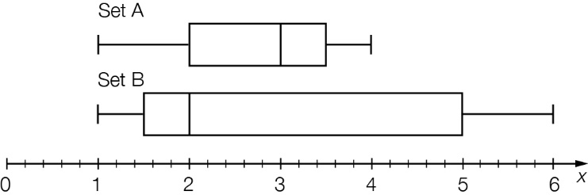

(b) Compare the statistics for the two data sets.

- The five-number summary for this box plot is: [1]

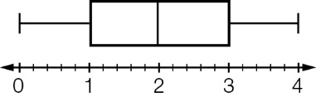

A 1, 2, 3, 4, 5 B 0, 1, 2, 3, 4 C 0, 1, 1, 2, 4 D 0, 1, 2, 2, 4

